TIME: 1 HOUR
DATE: 07-09-2023

Q – 1]
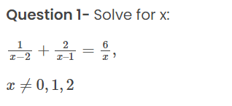

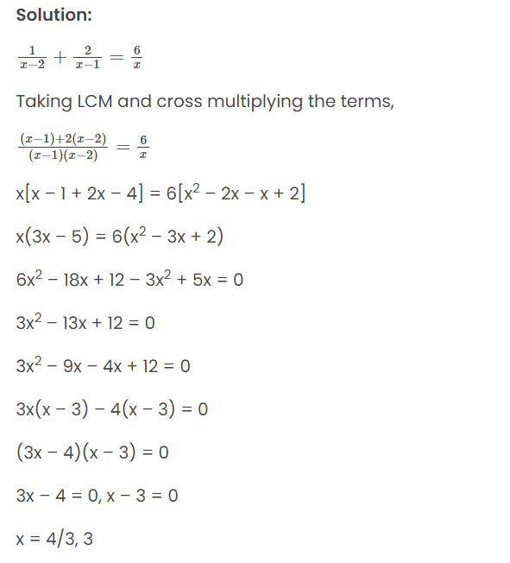
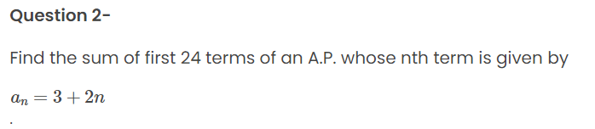
Solution:
Given,
a_{n} = 3 + 2n
Substituting n = 1, 2, 3,…
When n = 1,
a₁ = 3 + 2(1) = 3 + 2 = 5
When n = 2,
a₂ = 3 + 2(2) = 3 + 4 = 7
When n = 3,
a₃ = 3 + 2(3) = 3 + 6 = 9
Thus, the AP is: 5, 7, 9,…
Here,
First term = a = 5
Common difference = d = 2
We know that,
Sum of first n terms of an AP = S_{n} = (n/2) [2a + (n – 1)d]
Now,
S₂₄ = (24/2) [2(5) + (24 – 1)(2)]
= 12[10 + 23(2)]
= 12[10 + 46]
= 12 × 56
= 672
Therefore, the sum of the first 24 terms of the given AP is 672.

Q – 3]
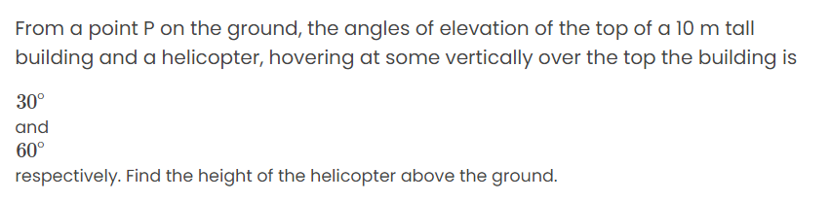
SOLUTION:
Let P be the position of a point and C be the position of a helicopter.
Height of the building AB = 10 m
AC = x m
PA = y m
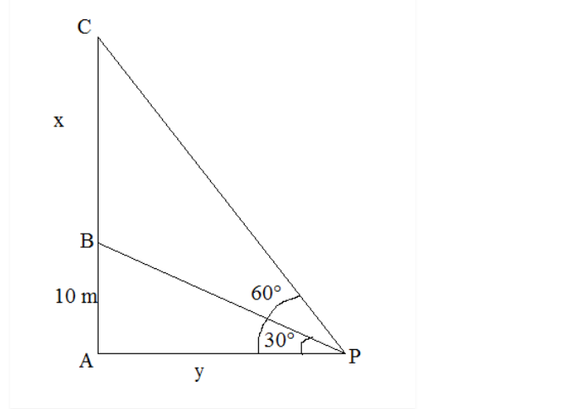
In right triangle PAB,
tan 30° = AB/PA
1/√3 = 10/y
y = 10√3 m
In right triangle PAC,
tan 60° = AC/PA
√3 = (x + 10)/10√3
10√3 √3 = x + 10
x = 30 – 10 = 20
Therefore, the height of helicopter from the ground = x + 10 = 20 + 10 = 30 m

Q – 4] Prove that √5 is an irrational.
Q – 5] Check whether 6^{n} can end with the digit 0 for any natural number n.
Solution:

